Citi Bike Study:

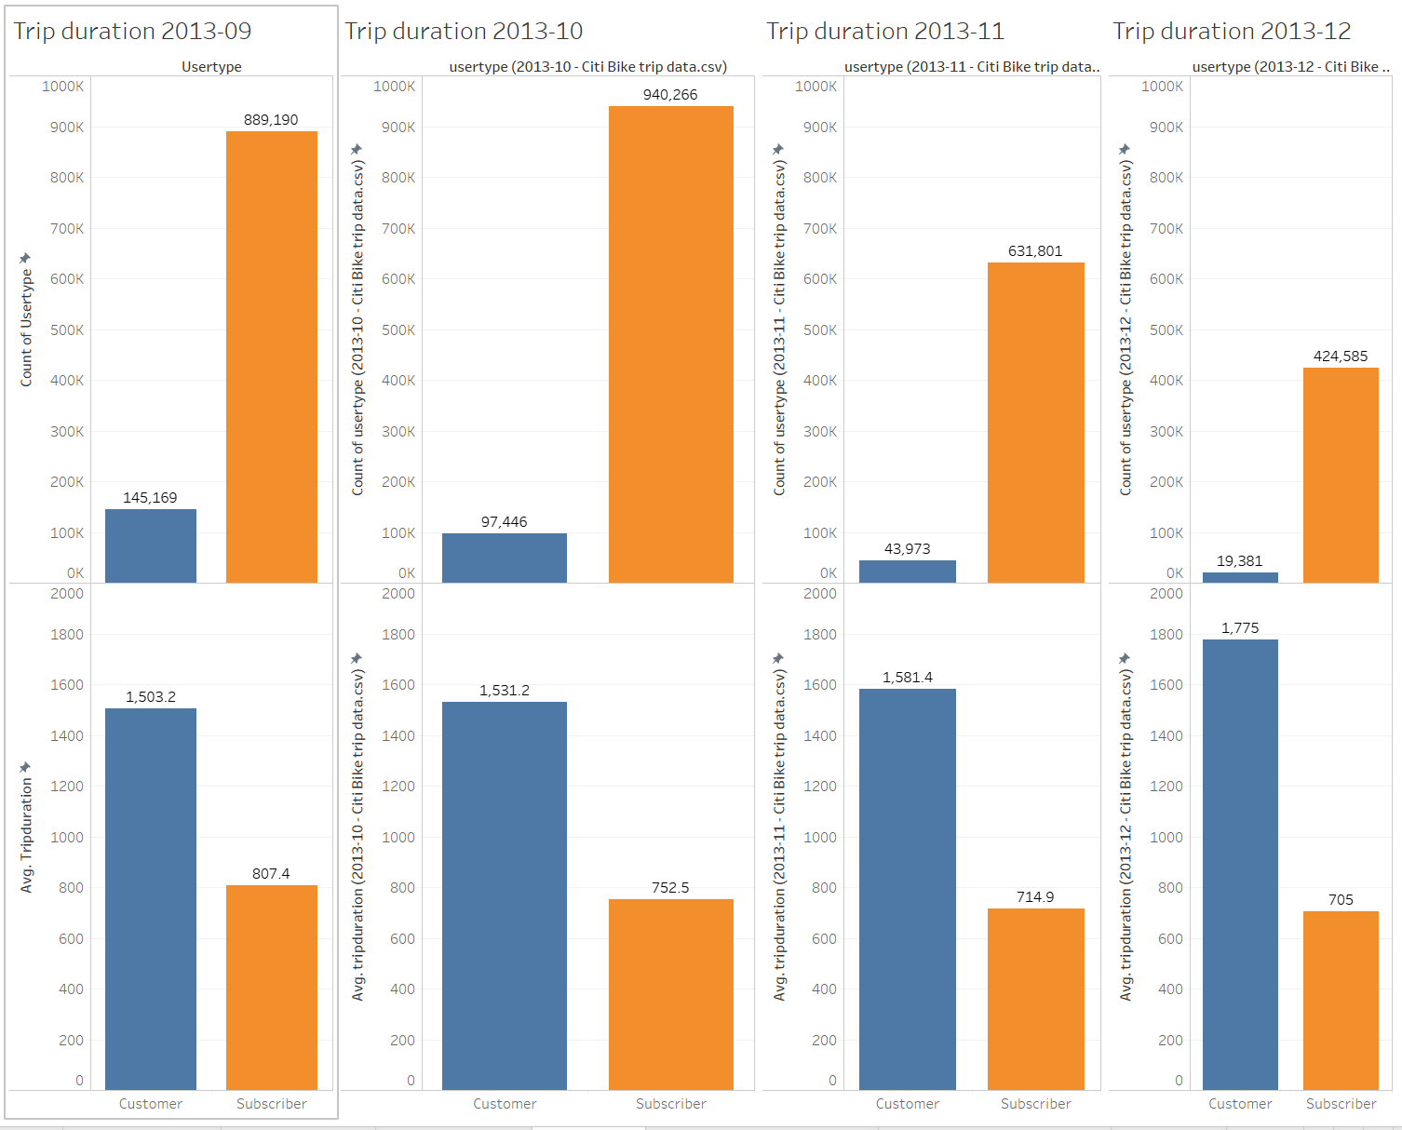

First, we take a look at the number of users we had each month from September 2013 to December 2013. As we can see from the graph above, the number of Non-Subscribers had a downward slope starting from 145k users in September and reaching only 19k users in December. As for Subscribers, a peak was hit in October with 940k users reaching its lowest point in December with only 425k users.

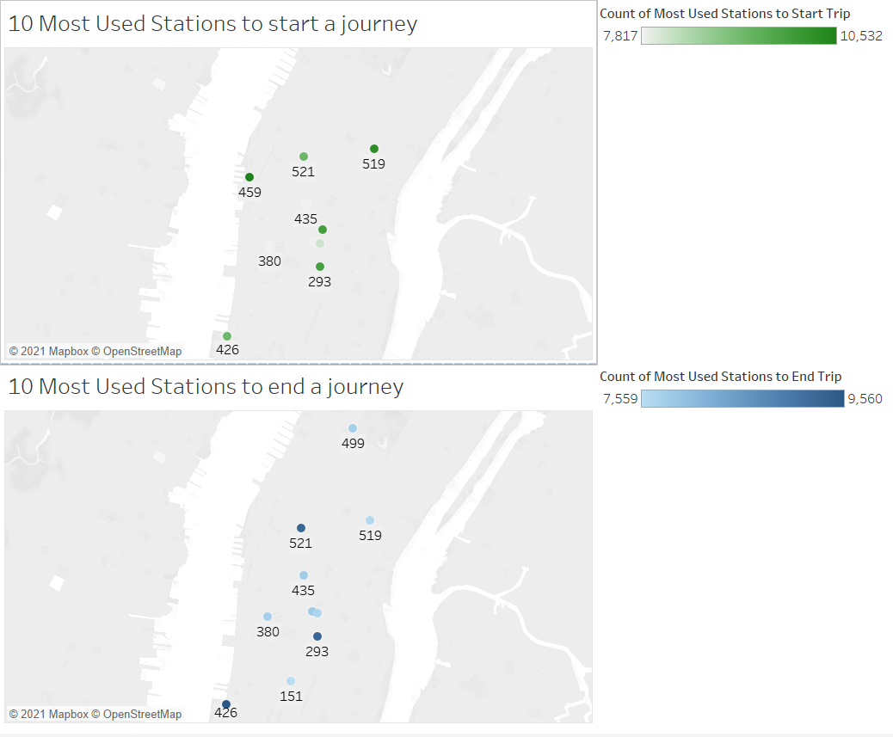

The most used station to start a journey in September was Station #459 in Midtown (Zip:10001) and to end a trip was station #426 in the Chelsea neighborhood (Zip: 10001).